Library Access for Alums

1. Complete the form here to create your account. It’s FREE!

2. You will receive an email from OpenAthens to login. Check your spam/junk folder if you don’t see it.

Then go to MyOpenAthens to login:

https://my.openathens.net/auth?entityID=https://idp.eduserv.org.uk/openathens
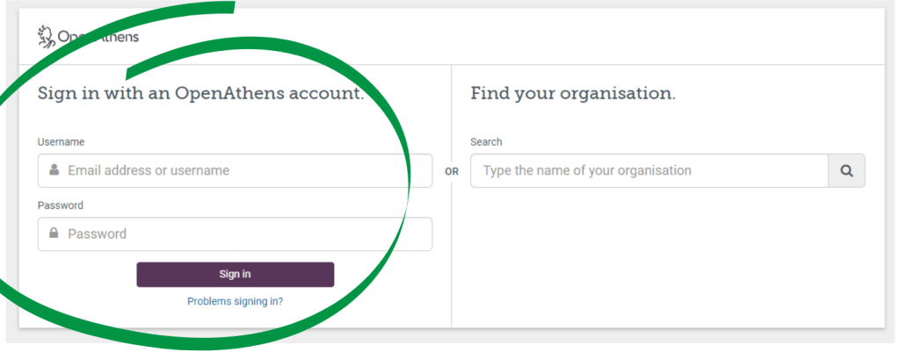

3. The homepage will look like the screenshot below:

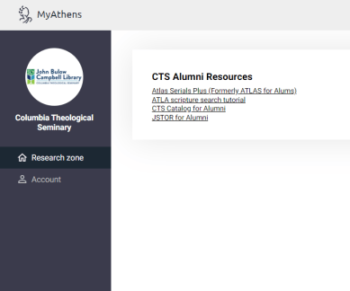

Check-out Privileges:

The library provides alumni lifetime check out privileges for the main library collections. Alumni can check out up to 6 items for 28 days. The library will mail physical resources to alumni for free. Alumni are expected to send the items back on or before the due date. Graduates are automatically switched to the alumni patron category.

